Community Health Assessment
Executive Summary
February, 2012

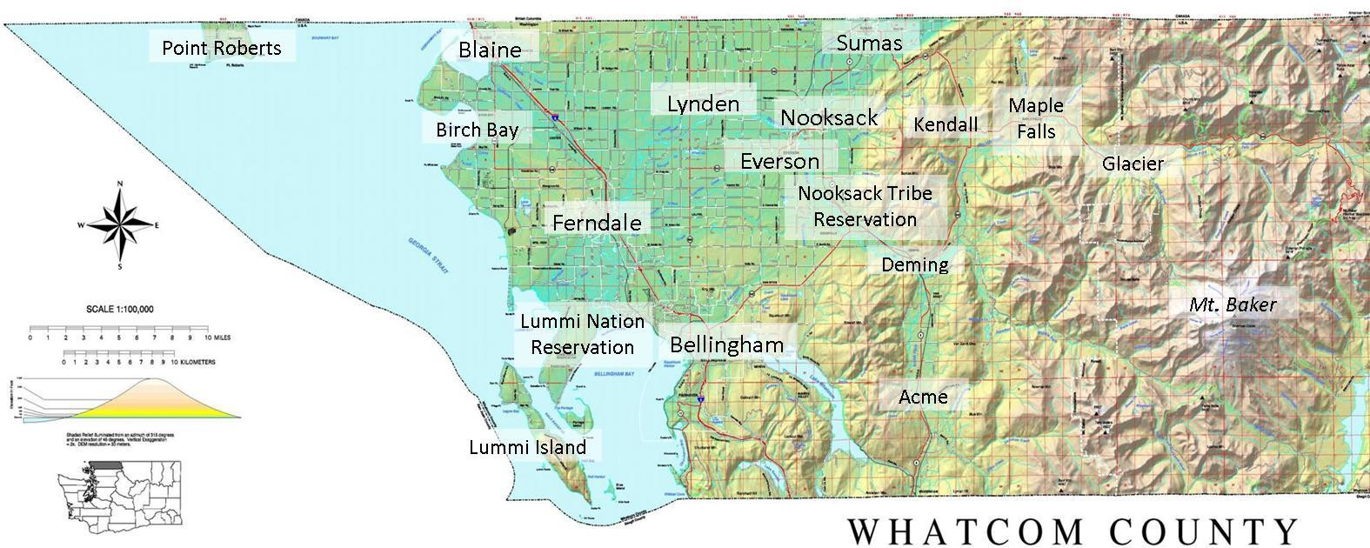

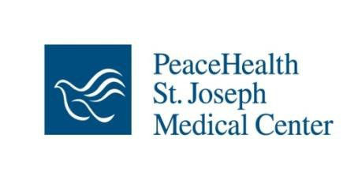Version 2.6
Revised April 2013

- Table of contents
(they did not include one)
2.Overview

Method
In the fall of 2010, Whatcom County Health Department and PeaceHealth St. Joseph Medical Center launched a comprehensive community health assessment and planning process. Undertaken in collaboration with a wide range of community partners, the overall aim of this work was to identify key areas where the community can take action to improve community health and reduce health disparities. The assessment also fulfills public health accreditation and health care regulatory requirements.

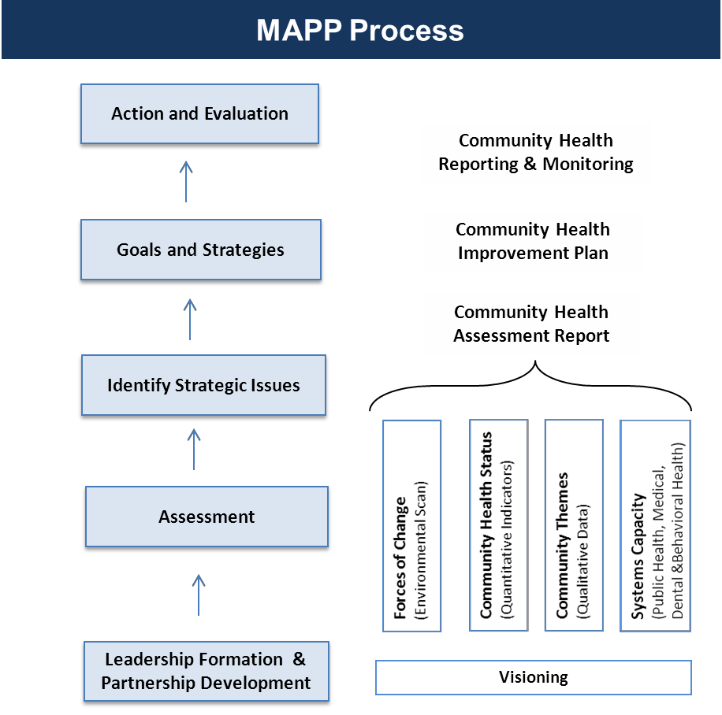The assessment process is based on the national Mobilizing for Action through Planning and Partnerships (MAPP) model, an evidence-based community- wide strategic planning process for improving community health.

This document is a summary of the four assessments that were completed in a nine month period in 2011.

Leadership

Gib Clarke, Interfaith Community Health Center Regina Delahunt, Whatcom County Health Department Susan Given-Seymour, Northwest Indian College
Rosalinda Guillen, Community to Community Development
Mauri Ingram, Whatcom Community Foundation

Liz Mogford, Ph.D., Western WA University
Sue Sharpe, St. Luke’s Foundation
Peter Theisen, United Way
David Webster, City of Bellingham
Greg Winter, Opportunity Council

Core Group
Laurie Brockmann, MPH, MSW
Michael Massanari, MD, MS, Critical Junctures Institute Astrid Newell, MD, Whatcom County Health Department Chris Phillips, PeaceHealth St. Joseph Medical Center

Summary of Findings

Community health status
  - People in Whatcom County are generally healthy.
  - Despite overall good health, challenges and disparities are hidden among the averages.
  - Poverty and adversity threatens the health and well-being of a significant portion of our children and young families
  - Mental health and substance use are frequently identified as high priority issues
  - We are well positioned to respond to federal health care reform, but basic issues of access remain for certain populations.

Forces of change and community themes
  - Whatcom County is becoming older and more ethnically diverse
  - Time of profound change for service providers
  - Food and nutrition seen as key focus areas
  - Housing and the built-environment are increasingly recognized as contributing to good health
  - Dynamic tension exists between environmental protection and development interests
  - Communities that are disproportionately impacted by health and social issues have limited voice in community decisions, and have much to offer.

Strategic Areas for Community Health Improvement

Healthy Children and Families
    - Healthy Active Living
    - Health Care Access and Service Delivery
    - Substance Abuse
    - Community Voice and Engagement
    - Health Data and Metrics

Next step is to set priorities, goals, objectives and action steps

The complete assessment report and copies of this document can be downloaded at http://www.co.whatcom.wa.us/health/index.jsp


Health Rankings summary Table

(this is a great table, I would like to see a table like this)

The table below lists health indicators that were used in determining the annual County Health rankings in 2011. Strengths reflect health indicators that were better than the state and national averages or benchmarks. Indicators listed under “Room for Improvement” were similar to the state averages, but may be areas of concern for some population groups. Challenges reflect areas where Whatcom County is worse than state and national averages and benchmarks, and where additional
focus is likely warranted.

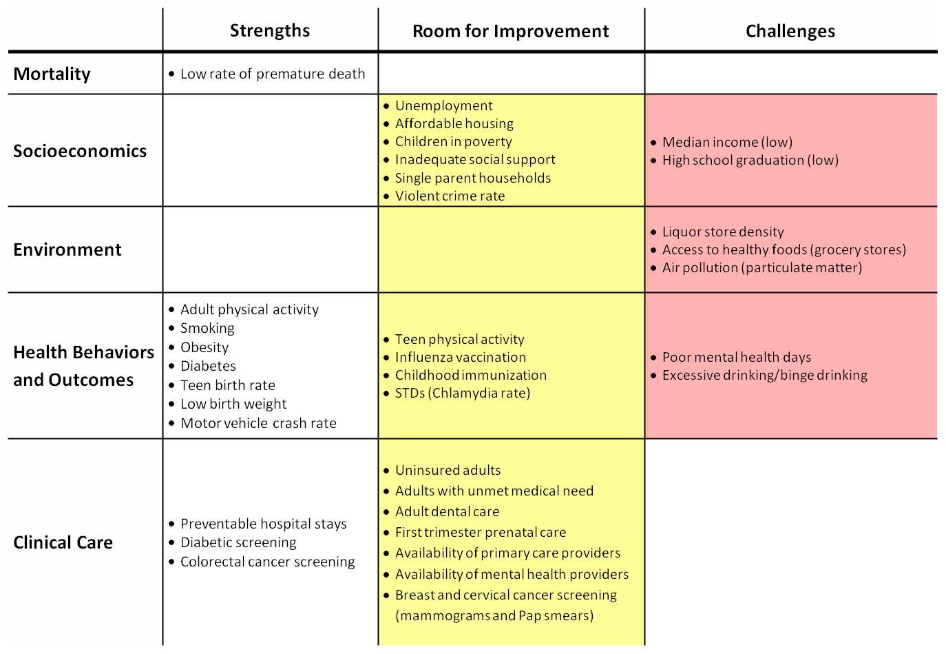

Source: County Health Rankings, 2011

http://www.countyhealthrankings.org


Areas where the People of Whatcom County are generally healthy

In 2011, Whatcom County was ranked the sixth healthiest county among 39 counties in Washington State in the annual County Health Rankings, a project of the Robert Wood Johnson Foundation and University of Wisconsin Population Health Institute.

Whatcom County ranked in the top 10 best counties in WA state for health outcomes, (how long people live and how healthy people feel) and health factors (health behaviors, clinical care, social and economic, and the physical environment).

High life expectancy

Residents of Whatcom County perceive themselves to be healthier than residents in comparable counties across the nation perceive themselves. The first graphic below demonstrates the proportion of respondents who consider their general health ‘fair’ to ‘poor.’ Note rates that are well below those reported for the nation.

Positive personal assessment of health is affirmed by objective measures of life expectancy that indicate residents, on average, outlive residents in comparable counties in the nation. *

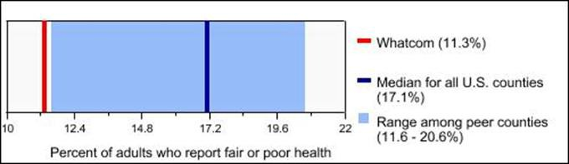
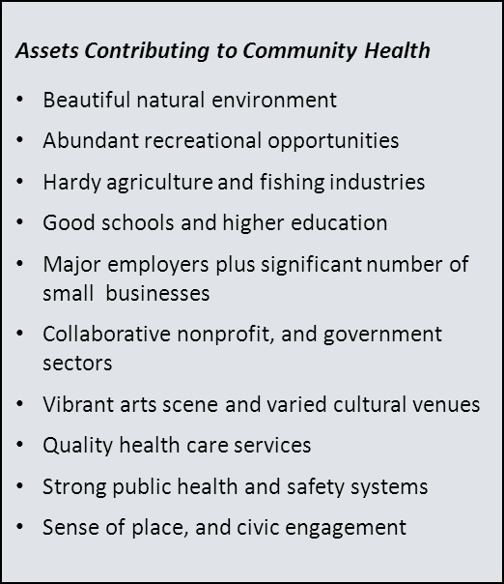Self-reported poor health status

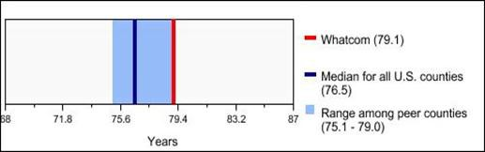
Life expectancy of Whatcom County residents

Source: County Health Rankings, 2011

* Note: The United States is only 50th in the World in Life Expectancy at 78.37 years. This trails behind other large industrialized nations, including the European Union as a whole (78.82 yrs), South Korea, (79.05-79.92 yrs), Australia (81.07-81.81 yrs), and Hong Kong, Singapore, and Japan (82.04-82.25 yrs).

3. Community Profile

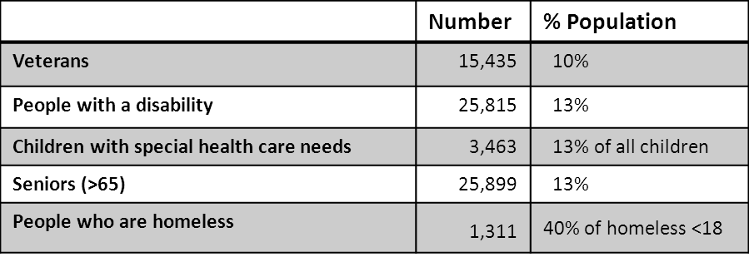

Growth

- The population of Whatcom County has been increasing, faster than the state as a whole. There has been a 21% increase in total population from 2000 to 2010 (from 166,814 to 201,140), compared to 14% for Washington State. (U.S. Census, 2010)
- Significant portions of the population have specialized health needs.

Aging of the population
- Over the past decade, the population of middle-aged adults (aged 40-64 years) grew by 31% (compared to 25% for the state), and older adults (65+ years) grew by 37% (compared to 25% for the state).

Ethnic diversity

  - Hispanic population increased more than 80% from 2000 to 2010.
  - Approximately 5% of the population
speaks Spanish at home (8,904 people)
  - One percent of the population speaks Slavic languages at home (1,773 people)
  - Approximately 3% of the total population is American Indian/Alaska Native

Sources: ACS 2009; OSPI 2010; Whatcom County Point-in-Time Homeless Count 2011

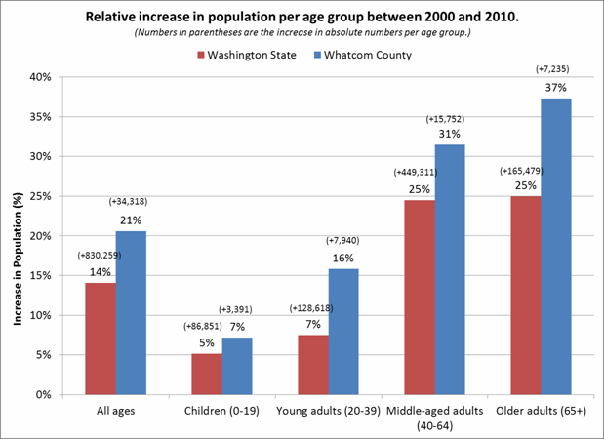
Source: US Census, 2010

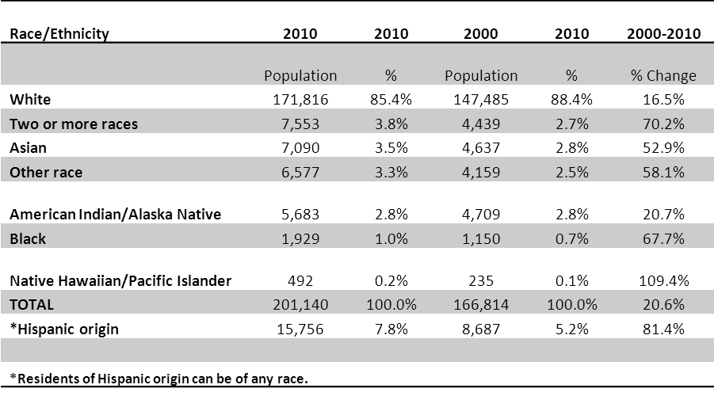Whatcom County race and ethnicity, 2000 - 2010
2000

Source: US Census, 2010


Health status is linked to Social Determinants of Health

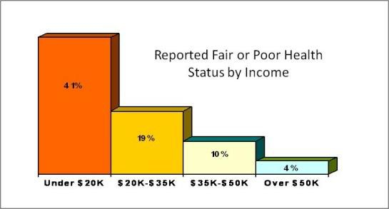

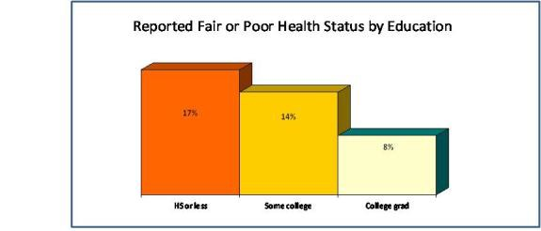

Source: Whatcom County BRFSS, 2007

Per capita mean income is highest for Whites. In particular, individuals of Hispanic/Latino origin have considerably less income than any other race or ethnicity in Whatcom County.
Source: WA Dept of Health, 2011 (Data from US Census
Bureau, American Community Survey 2005-2009)

Whatcom County data demonstrate strong associations between income and self-reported health status of adults, with a significantly greater percentage of people in households at lower income levels reporting poorer health status than those with higher household income.

Individuals who have a high school diploma or less, are more likely to have poor or fair health status than individuals with a college degree.

Whatcom County Per Capita Mean Income

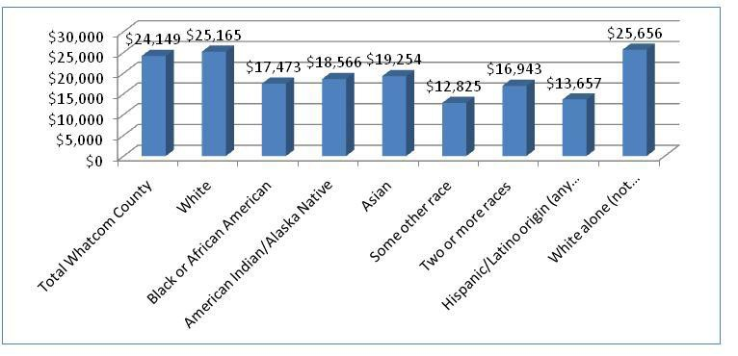
Source: US Census Bureau, American Community Survey, 2009

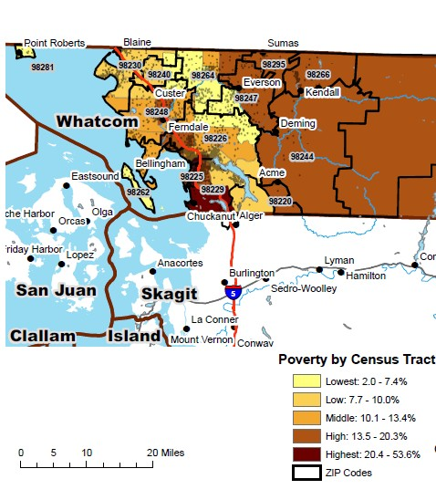Pockets of vulnerable populations. A greater percentage of older adults live in Lynden than other parts of the county. Russian speaking immigrant populations are concentrated in eastern Whatcom County. Hispanic populations are concentrated in agricultural areas of Lynden and Everson/Nooksack as well as in north Bellingham. American Indian tribal populations live primarily on reservation lands on Lummi Peninsula and Deming areas. Pockets of poverty are distributed throughout the county, however percentages of families living in poverty are higher in the eastern part of the county as well as in central and northern Bellingham and Ferndale.
Whatcom County Poverty Distribution

Housing and the built-environment are increasingly recognized as
contributing to good health

Safe, healthy homes and neighborhoods provide an important foundation for healthy living. Affordable, safe homes contribute to residents' stability and sense of security. "Families with difficulty paying rent or housing-related bills face increased acute care use and emergency room visits." (SSIR, Summer 2012, vol. 10, no. 3, pg. 30) Walkability and bikeability – the abilities to live reasonably well without a car – have economic as well as physical and emotional health benefits. Even if residents need a car, they can spend less on gas and maintenance if amenities are located in close proximity to their homes. Community design and amenities such as sidewalks, parks, and community centers can create opportunities for positive social interaction and enhanced safety which also contribute to health and well-being.

Affordable housing out of reach for many. Almost half of all Whatcom County residents do not have affordable housing: 55% of Whatcom County renters and 44% of owners with mortgages spend more than 30% of their household income on housing. (US Census Bureau, American Community Survey, 2010)

Access to safe walking and biking variable. There is great variation in Whatcom County between geographic areas in terms of potential “walkability” or “bikeability.” Bellingham is rated as a “Walker’s Paradise,” Ferndale is “very walkable”, Lynden is “somewhat walkable,” and all other areas are “car-dependent” as determined by an electronic Walk Score® tool .
(Whatcom ACHIEVE, 2009)

- Leading Causes of Death tables
(this county did not include these in their executive summary)


5. Disparities: despite overall good health, challenges and disparities are hidden among the averages

3 out of 5 Whatcom County adults are overweight or obese

- Less than half of Whatcom County adults have a healthy weight;
34% are overweight, 26% are considered obese.

- Being overweight is associated with age.
(50-64, and 65 and older), being male, having annual household incomes over $50,000.
- Obesity is associated with having low annual household income (under $20,000/year), less education, residing in rural areas.

One-third of lower income adults smoke
- Tobacco use is more common in lower income and lower education groups.
- 18% of all adults in Whatcom County are current smokers, compared with 36% of adults with annual household income less than $20,000.
Health Risk and Income
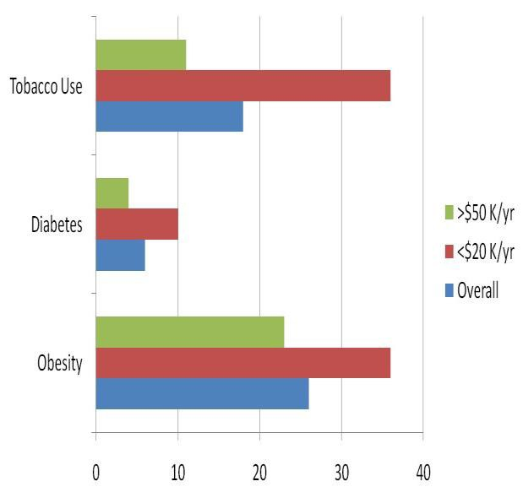
%
%
%
%
%
Source: Whatcom County BRFSS, 2007

Diabetes is more common in lower income populations

- The prevalence of diabetes has been increasing and is now 6% in Whatcom County.
- While this ranks in the lowest quartile across the nation, the prevalence of diabetes among American Indians is higher than any other ethnic group. Rates are also higher in Hispanics than non-Hispanic Whites.
- Ten percent of adults with low annual household income (<$20,000) have been diagnosed with diabetes compared with only 4% of adults with higher annual household income (>$50,000).

American Indians and Blacks in Whatcom County more likely to die early

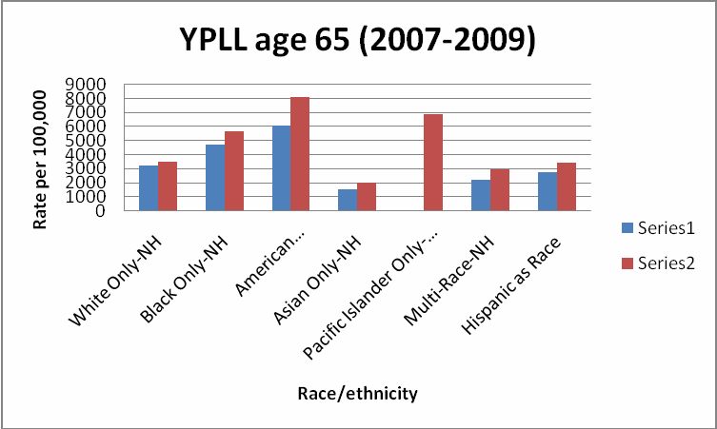Years of potential life lost (YPLL) is a measure of premature death. The younger someone is when they die, the more years of potential life lost. Data from Whatcom County demonstrate that American Indian/Alaskan Natives and Blacks have significantly more years of potential life lost than Whites, Asians, Hispanics. These trends follow similar patterns to the state.
Whatcom

WA State

Source: WA DOH CHAT, accessed 2011 8

People in Whatcom County that experience social disparities include:

- Individuals and families living in poverty, particularly women, children and seniors
- Racial/ethnic minority groups (Hispanic, American Indian, Black)
- Immigrant and migrant populations
- Geographically isolated groups
- People who identify as lesbian, gay, bisexual, transgender, or questioning (LGBTQ)
- Children and adults with developmental and physical disabilities or challenges
- Individuals with mental illness and/or chemical dependency
- Veterans returning from military service
- Homeless individuals

Keys areas of need

(this county combined the discussion of lifestyle and behavior with key areas of focus; they spend a long time on key areas of focus)

Food and nutrition seen as a key focus area

  - Growing rates of obesity and diabetes among adults and children are a particular concern for population groups, including lower income, Hispanic and tribal populations.
  - Overweight is an issue for all ages and income groups and most racial/ethnic groups including Whites.
  - Local obesity trends follow national and global trends and are related to unhealthy food environments and sedentary lifestyles.
  - Local food issues include:
    - concern about equitable access to healthy, culturally appropriate, affordable foods
    - hunger and food insecurity
    - farm worker health and safety
    - development of local food growing and distribution systems.

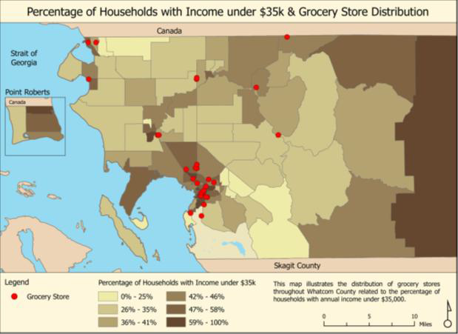

The map above shows the distribution of grocery stores across the county related to the percentage of households with incomes under
$35,000/year. The map demonstrates the lack of access in rural areas, as well as the lack of access in certain impoverished areas such as in the east county area. (Whatcom County Community Food Assessment, 2011)

18

b) Health and well-being of children an important community concern

Impact of adverse childhood experiences

Mounting scientific evidence points to the strong connection of childhood experience with health behaviors and conditions.
Washington state data demonstrate that individuals who experience adversity (such as abuse, neglect, or family dysfunction) in childhood are more likely to engage in risky health behaviors and to have worse health status as adults.

The risk for poor health outcomes increases for individuals with more adverse experiences.
Relationship of ACE’s to Chronic Conditions in WA

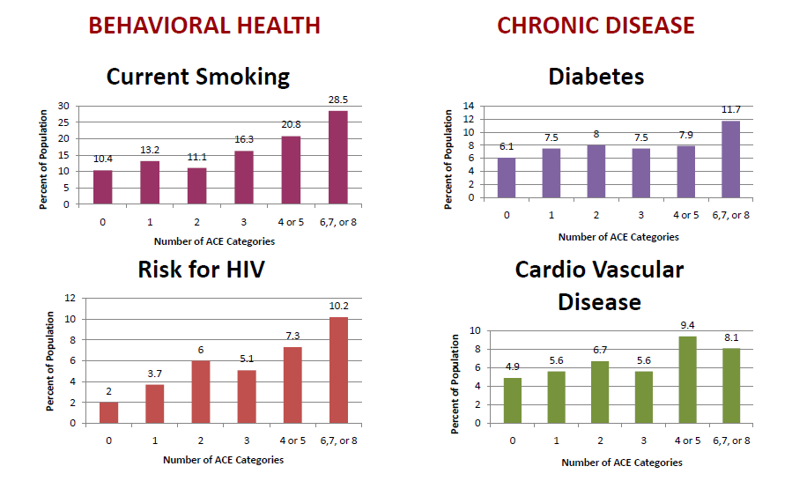Graphic Source: WA State Family Policy Council, 2010. Data Source: WA State BRFSS 2009

Higher rates of child abuse and neglect than in the state

  - In 2010, at least 1,592 children (0-17 years) were victims of child abuse and neglect in Whatcom County. The rate of accepted referrals to Child Protective Services in Whatcom County was 37.72 per 1000 children, compared to the Washington rate of 29.80 per 1000 children. (WA DSHS, 2011) Whatcom County rates of abuse have been consistently higher than state rates since 2004.
  - Racial/ethnic minority populations and low income families are disproportionately impacted.
  - Parental substance use and mental health issues are often contributing factors to child abuse and neglect.

Poverty and family health
Having adequate, stable financial resources is critical for a healthy family to function, allowing families to meet their basic needs and support healthy child development. Poverty creates stressors that impact all family members, but are especially detrimental to young children.

In Whatcom County, poverty affects:
    - More than 6,000 children under age 18 years (16.4% of all children)
    - One third (27.9%) of single mothers and two thirds (62.6%) of single mothers with children under 5 years
    - More than 40% of American Indian, Black and Hispanic single mothers
Source: US Census Bureau, American Community Survey 2009 10

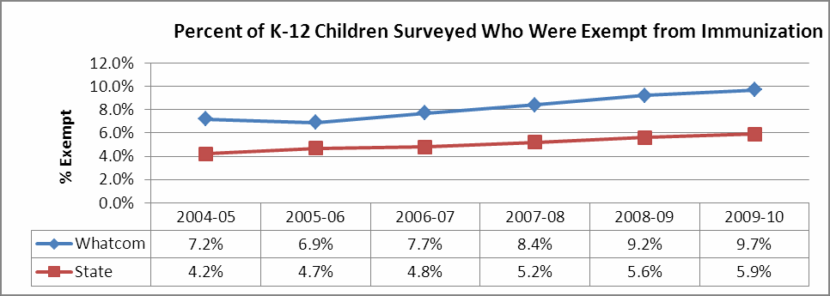Preventing childhood health conditions
Many serious childhood health conditions, such as obesity, infections, and dental cavities can be prevented. Opportunities exist to improve child health by increasing preventive health behaviors.

Breastfeeding Immunizations

  - Approximately 90% of WIC mothers in Whatcom County initiate breastfeeding, but the majority stop earlier than recommended, many within the first weeks of life. (WCHD, 2011)

Dental Health
  - 61% of 3rd graders have tooth decay experience, 13% are untreated.
  - Low income and Hispanic children have more decay and receive less treatment.
  - 56% of 3rd graders with dental sealants
(higher than Healthy People 2010 target)
Source: Whatcom County Smile Survey, 2010
- Less than 70% of young children fully immunized
(National Immunization Survey, MMWR, 2011)
- High rates of vaccine preventable illness (e.g., pertussis)
\
- School immunization exemption rates consistently
worse than the state

Source: WA DOH Immunization Program, 2011


c) Substance use and mental health important community concerns

High rates of substance abuse

▪ Illicit drug use is significantly higher in Washington State and the region that includes Whatcom County (9.9%) than the national average (8.1%). (SAMHSA, National Survey on Drug Use and Health, 2006, 2007, and 2008) This is true for all classifications, including marijuana, cocaine, and the non-medical use of pain relievers and other substances. The same is true of alcohol use, with both the State and the county consuming greater amounts than the national average.

▪ Rates of drug associated health and social problems such as violent crime and hepatitis C are growing. Increasing rates of drug-affected newborns and high rates of child abuse and neglect referrals associated with parental heroin addiction are particularly disturbing.

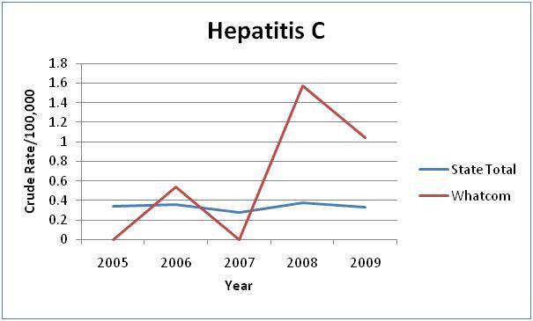Hepatitis C is a viral infection of the liver that may produce chronic, persistent infection associated with cirrhosis, hepatic failure, and death. Hepatitis C is contracted from exposure to contaminated blood (blood from infected patients) and/or sexual contact. The striking increase in incidence of Hepatitis C in Whatcom County is consistent with an epidemic and likely related to increasing IV drug abuse in the county.

Drug Trends 2000-2009
Source: WA DOH-CHAT

The following graphics prepared by the Alcohol and Drug Abuse Institute at University of Washington demonstrate the significant increases in prescription opiate and heroin use (as measured by police evidence data) over the past decade. Heroin use is particularly high in Whatcom County.
Opiate Rx 2000 Opiate Rx 2009

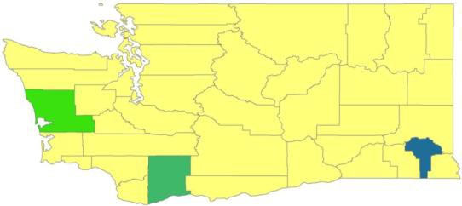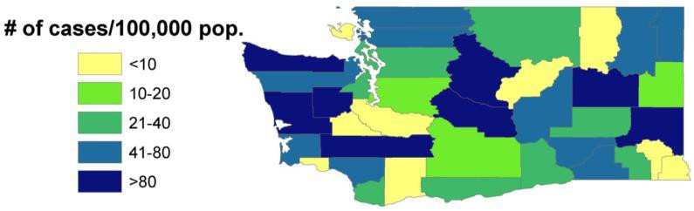
Heroin 2000 Heroin 2009

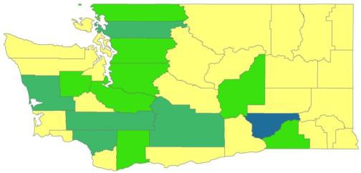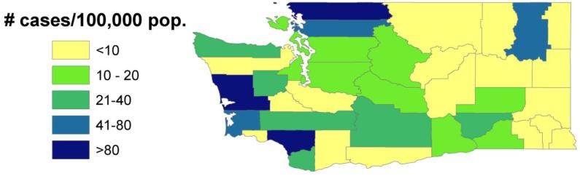

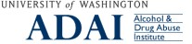

Additional Data: http://adai.uw.edu/pubs/infobriefs/ADAI-IB-2011-03.pdf 12

Alcohol, cigarette and other drug use by school age youth
While Whatcom County rates of school age youth using alcohol, cigarettes and other drugs is consistent with State data, rates of substance use among youth is nevertheless concerning.
SUBSTANCE USE |  | GRADE IN SCHOOL
 |  | 6th | 8th | 10th | 12th
Cigarettes in past 30 days
 | Whatcom County | 0.9% | 6.4% | 13.8% | 18.3%
 | WA State | 1.7% | 6.4% | 12.4% | 19.1%
Marijuana use in past 30 days
 | Whatcom County | 0.9% | 8.8% | 22.5% | 24.1%
 | WA State | 1.6% | 9.2% | 19.0% | 26.2%
Alcohol use in past 30 days
 | Whatcom County | 2.3% | 13.7% | 32.3% | 40.5%
 | WA State | 3.8% | 14.0% | 27.5% | 39.9%
Prescription Painkillers (used past 30 days without prescription)
 | Whatcom County |  | 3.9% | 10.1% | 8.1%
 | WA State |  | 4.2% | 8.2% | 7.8%
Ritalin (used past 30 days without prescription)
 | Whatcom County |  | 3.1% | 4.8% | 6.5%
 | WA State |  | 1.8% | 3.6% | 4.1%

In a survey of WWU students:
- 46% report marijuana use
- 36% report binge drinking in the past 2 weeks
- 17% report hallucinogens or recreational drug use
(WWU Student Health Survey, 2010)

Source: WA DOH Healthy Youth Survey, 2010

Depression and Suicide

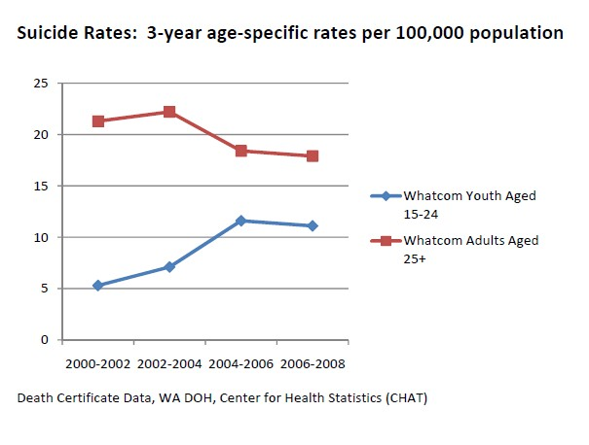▪ The suicide rate is higher in Whatcom County than the state and nation. The suicide rate for Whatcom County is 19.3 per 100,000 which exceeds the state rate of
13.3 per 100,000 and is significantly higher than peer counties across the nation. (DOH- CHAT 2009) Suicide (attempts and completed) is a particular issue in the Native American/American Indian communities.
▪ Ten percent of Whatcom County adults reported experiencing poor mental health lasting two or more weeks in the past month. (Whatcom BRFSS 2007) Maternal depression (during and after pregnancy) is common.
▪ Depression is also prevalent among high school and university students in Whatcom County. One out of four high school students (28.6% of 10th graders)* and one out of five WWU students (18.8%) ** report clinical depression symptoms or history of depression diagnosis. High school rates are similar to the state. The depression prevalence at WWU is higher than rates reported nationally (14.9 %).

*High school data: Healthy Youth Survey 2010
**College data: National College Health Assessment 2008 (WWU)
13

d) Access to Care and Important Community Health Concerns

Despite abundant health care resources, access remains a challenge for some people. Access issues include financial, geographic and cultural barriers. Dental care for adults and behavioral health care for children and adults are frequently identified as particular problems. Lack of primary care resources in rural and isolated areas are also on the radar.

An estimated 13% of adults (19-64) lack health insurance
- The rates are even higher for adults who live within 200% of the federal poverty level. (OFM, 2011)

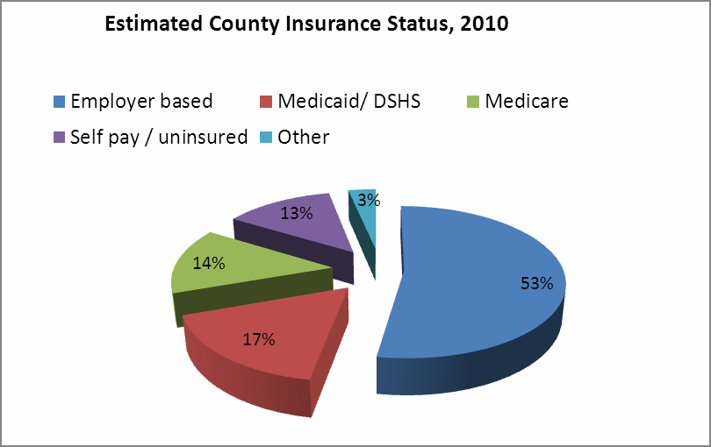Most kids are covered
- Because of more generous state insurance programs for children, only 3% of children are uninsured in Whatcom County. (Kids Count, 2010)

Under insurance a growing problem
- 46% of all people qualifying for PeaceHealth SJMC financial assistance in 2010 were insured with high deductible health insurance.

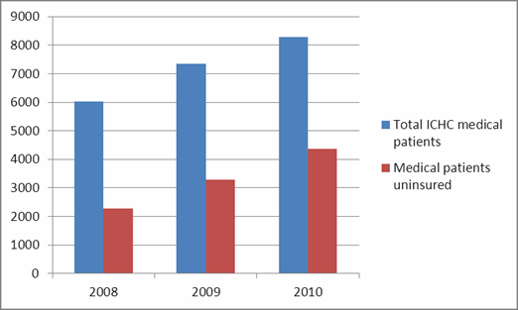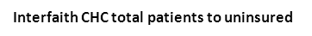Access to care
Source: WA-OFM, 2011

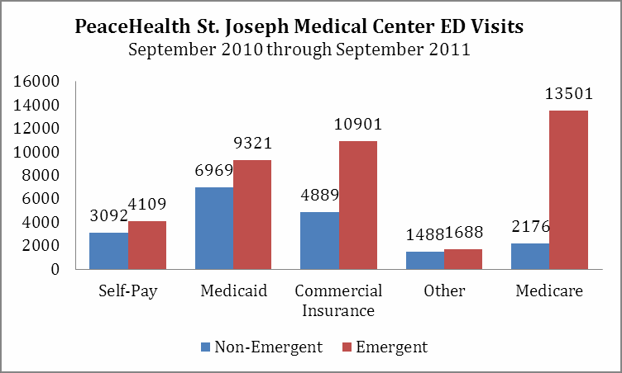
  - The percentage of uninsured Interfaith Community Health Center patients has shown steady increase over the last three years. (ICHC, 2011)
  - 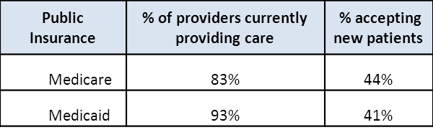Even when residents have insurance (Medicare, Medicaid) they are not ensured access to medical care as illustrated below. According to the 2010 WA DOH Primary Provider Survey, more than 80% of physicians in the community provide care for patients with publicly funded insurance. However, less than 50% accept new patients when covered only by public insurance.

Avoidable Emergency Department (ED) visits

    - People without insurance or people who have Medicaid tend to use the ED for non-emergency care more than people who have health insurance as evidenced by 2011 data from PeaceHealth St. Joseph Medical Center.

7. Recommendations: Key Questions for Improving Community Health

Healthy Children and Families  How do we reduce and mitigate adversity in childhood and optimize healthy child, youth and family development? | Community Voice and Engagement  How do we create a more inclusive community where all people feel that their voices are heard and they can actively participate in community life without fear and stigmatization?
Health Care Access and Service Delivery How do we reduce barriers to health care and improve service delivery to better meet health needs of vulnerable people?
Healthy Active Living  How do we increase opportunities for people to adopt healthy active lifestyles neighborhoods and communities? | Health Data and Metrics  How do we better measure and monitor health status and ensure progress towards community health improvement?
Substance Abuse and Chemical Dependency
How do we reduce use and abuse of harmful substances and associated social and health consequences?

8. Sources
(they cite the sources below each table, you can do this for class if you wish, but also put them at the end)

